Groundcrew.AI Stage 1

- Go to https://make.powerapps.com

- Sign in with your demo credentials, you should be brought to the page shown below

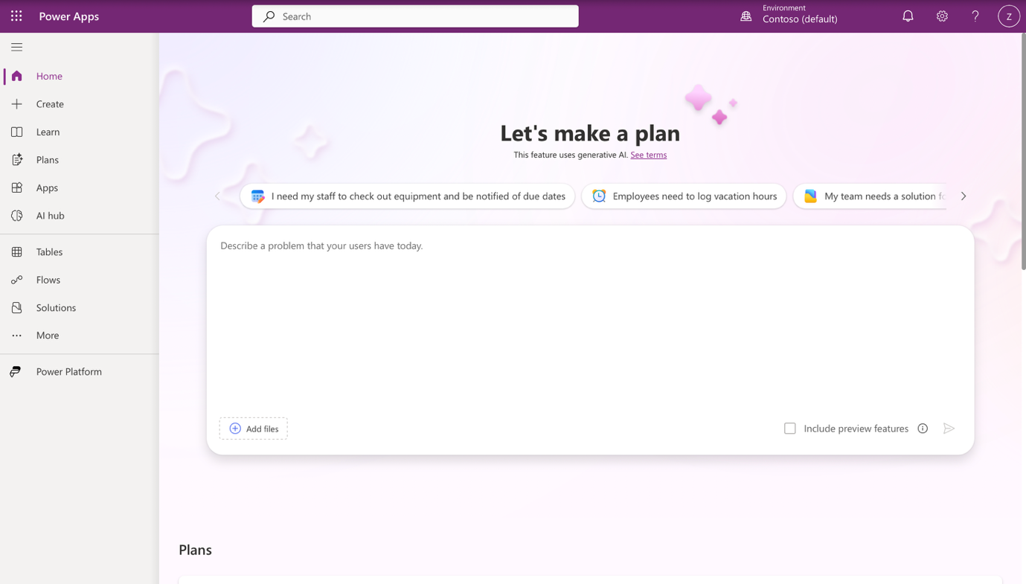
Ensure you are in the right environment. Check the top right, you should be in; Contoso (Default).

- On the left hand side panel, select ‘Tables’, then click ‘New Table’. (You might be prompted to create a new developer environment, click ok and take note of the environment name on the top right after your page refreshes)

- On the ‘choose an option to create tables’ page, choose to ‘Start from blank’

- Click the tab on top right of your ‘Table 1’ block and click view properties
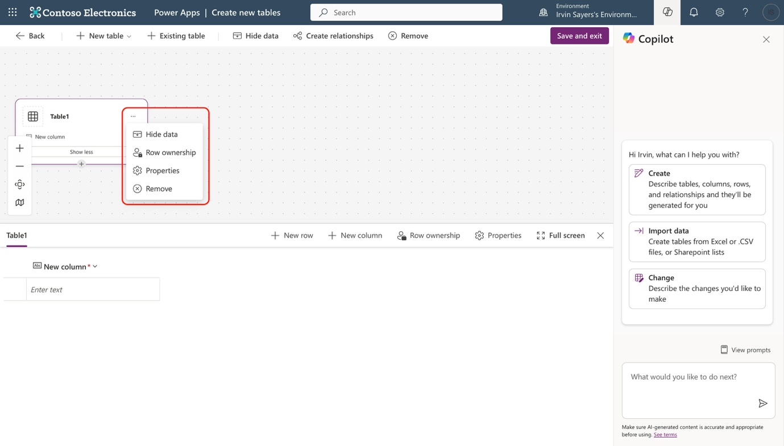

- Edit the Display name to “UserVerification” and plural name should automatically be “UserVerifications”. Then click ‘Save”

- On the table designer, click on ‘New column’ and choose to edit column, we will edit the first column that is auto created for us, then create the remaining columns.
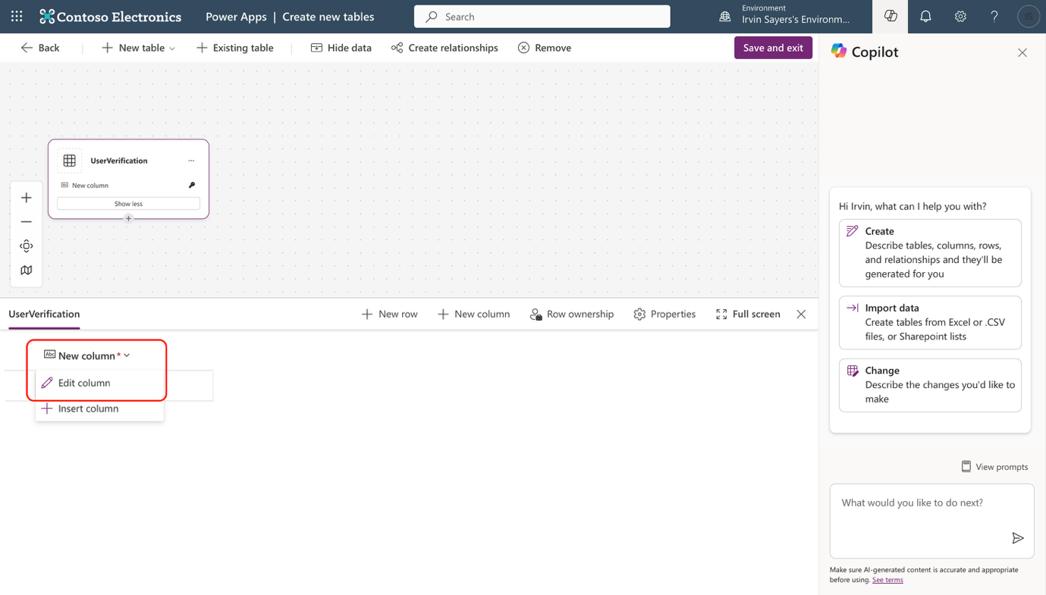
- Edit the first column with these details and click update
Column Name | Data Type | Required
Name | Single line of text | Yes

- Click ‘+ New column’ and add 4 new columns with the following details

Column Name | Data Type | Required
Email | Single line of text | Yes
Verification Status | Single line of text | Off
Headshot Status | Single line of text | Off
OTP code | Whole Number | Off

- Once you have all 5 columns, you may “Save and exit”
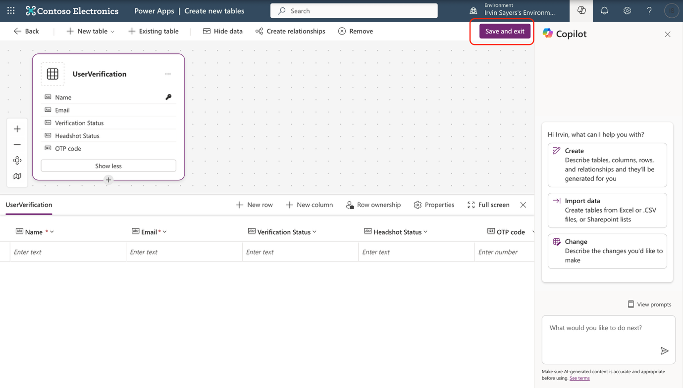

- Congratulations! You have created the table that is going to be used in building our agent and it’s flows!

